The new site is here: http://www.k9bytesgifts.com/new/

I made a copy of k9bytes.php in the new/k9bytes folder
Please update that file.

One thing I know needs to be changed to place an order is:
cardnumber1, cardnumber2, cardnumber3, cardnumber4
It should be changed to just cardnumber as there will be just one box for the numbers instead of 4
Will that need to be updated in the Admin too?

Can you figure out the loading problem on these pages (I know you are on the right track about loading an element first, but I haven’t figured out the fix yet):
http://www.k9bytesgifts.com/new/dog-collars.html
http://www.k9bytesgifts.com/new/holidaycollars.html
http://www.k9bytesgifts.com/new/dog-leashes.html
http://www.k9bytesgifts.com/new/holiday-leashes.html
http://www.k9bytesgifts.com/new/cat-collars.html
http://www.k9bytesgifts.com/new/holiday-cat-collars.html

All tables need to be changed to have no width and a class of table:
<table class="table">
The rest is taken care of by the CSS
I changed the RevCart table. (parse cart)
I’m sure there are more that need to be updated, like the confirmation page?

DATABASE

Three price levels: Retail, Wholesale, Drop Ship

Categories

Everyday Dog Collars
Patriotic & Camo Dog Collars
Bones, Paws & Animals Dog Collars
Flowers & Nature Dog Collars
Shapes & Stripes Dog Collars
Collars for a Cause
Holiday Dog Collars
4th of July Dog Collars
Christmas Dog Collars
Thanksgiving Dog Collars
Hanukkah Dog Collars
Halloween Dog Collars
Valentine's Dog Collars
Mardi Gras Dog Collars
St. Patrick's Dog Collars
Easter Dog Collars
Wedding Dog Collars
Everyday Dog Leashes
Patriotic & Camo Dog Leashes
Bones, Paws & Animals Dog Leashes
Flowers & Nature Dog Leashes
Shapes & Stripes Dog Leashes
Holiday Dog Leashes
4th of July Dog Leashes
Christmas Dog Leashes
Thanksgiving Dog Leashes
Hanukkah Dog Leashes
Halloween Dog Leashes
Valentine's Dog Leashes
Mardi Gras Dog Leashes
St. Patrick's Dog Leashes
Easter Dog Leashes
Wedding Dog Leashes
Everyday Cat Collars
Patriotic & Camo Cat Collars
Bones, Paws & Animals Cat Collars
Flowers & Nature Cat Collars
Shapes & Stripes Cat Collars
Holiday Cat Collars
4th of July Cat Collars
Christmas Cat Collars
Thanksgiving Cat Collars
Hanukkah Cat Collars
Halloween Cat Collars
Valentine's Cat Collars
Mardi Gras Cat Collars
St. Patrick's Cat Collars
Easter Cat Collars
Wedding Cat Collars

Dog Toys
Catnip Toys
Treats
Pet Blankets
Gift Boxes
Shampoo & Bath
Closeout
New

Notes
I am not going to have the “unique gifts” anymore, just the pet products.

Each product has an itemid. The system can assign product ID, and I will add an itemid. I want the itemid in the cart description as it currently is, i.e. Pumpkins Cat Collar, (CCPump)

I am adding a Description on each product, for instance:

Flag Dog Leash
Patriotic waving American flag stars and stripes
That description shouldn’t show in RevCart, just the Name and Product Number

The Navigation will have three versions: retail, wholesale and drop ship so that the links go to the correct product prices.

Each product needs its own header, as the info at the top is different. I also want to define the Title tag.

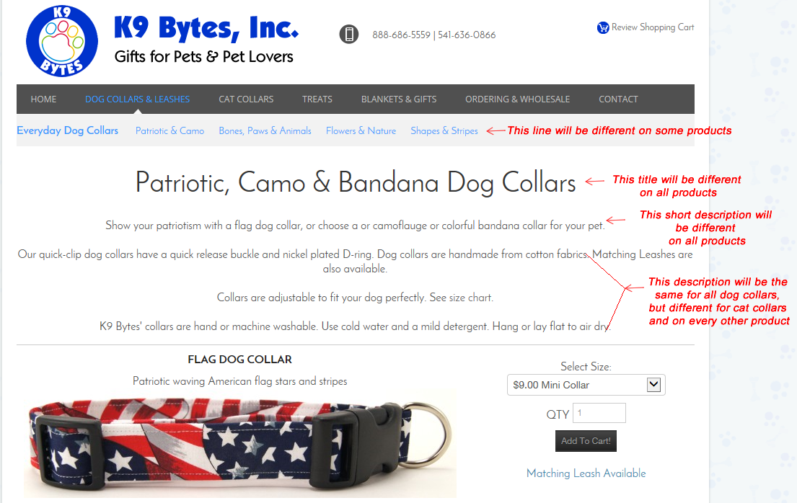

I am only using the Large images at this time (no thumbnail). There should not be a size added to the image scr. I will be sure to size the images correctly (600 pixels wide).

Dog collars have 5 size options, but not all patterns are available in all sizes (mini isn’t available in some).

Some dog collars should say: Matching Leash Available with a link to the corresponding leash

All dog leashes should say: Matching Collar Available with a link to the corresponding collar

